Advanced Molten Salt Heat Transfer and Thermal Storage Material for Central Receiver Solar Thermal Power Generation

Topic NM – Nanotechnology, Advanced Materials and Manufacturing
Subtopic AM7 – Smart and Specialized Materials

Identification and Significance of the Innovation
Halotechnics proposes developing a novel molten salt heat transfer and thermal storage material for central receiver solar thermal power plants. This material, to be named “Saltstream 700,” targets a melting point of 200 °C and a maximum operating temperature of 700 °C. This broad operating range is currently unavailable with any commercially feasible material in the marketplace.
It is imperative that we reduce our usage of natural gas and especially coal to address pressing societal concerns – climate change and environmental degradation, energy security, and price volatility. Solar thermal power, a compelling source of renewable electricity at large scale, represents a possible solution to fossil fuel use. With further technological advances, solar thermal power will become cheaper than natural gas or coal and able to provide electricity day and night. However, electricity from solar thermal power currently costs approximately $0.15 per kilowatt hour. This cost is too high to be directly competitive with fossil fuel-based power, which can cost $0.10 per kilowatt hour or less. Furthermore, although solar thermal plants have the capability of storing heat in order to produce power after sundown, this represents a significant capital cost to plant developers. The development of the proposed innovation would both reduce the cost of solar thermal power and enable economic thermal storage, bringing the nation significantly closer to eliminating the use of coal.
The solar thermal power market is an emerging industry with enormous growth potential. A recent report published by Greenpeace and the European Solar Thermal Electricity Association projects an installed capacity over 68,000 MW by 2020, enough to power over 50 million households []. Solar thermal power plants generate electricity by focusing sunlight using mirrors onto a receiver, then passing a fluid through the receiver to collect the heat, and finally using the heated fluid to boil water and drive a steam turbine generator. At the heart of these plants is the heat transfer fluid. The market for this crucial component is projected to reach $5.5 billion by 2020. It is possible to store large quantities of the heated fluid in an insulated tank during the day, and to discharge this thermal energy after sundown to continue generating power []. However, this storage represents an additional capital cost to the project developer and must be made cheaper in order to economically provide power from the sun day and night.
In order to achieve large scale commercial deployment and to compete with fossil fuels, there is a crucial need across the solar thermal power industry to lower costs and develop viable thermal storage. To achieve these goals solar technology developers are pushing to increase the operating temperature of their systems, thereby lowering their levelized cost of the electricity and reducing the cost of storage. High temperatures necessitate the adoption of molten salt heat transfer fluids and thermal storage materials (synthetic oil would break down and steam would generate excessively high pressure). The Department of Energy has funded millions for molten salt technology development, most recently a grant for $62 million awarded to several companies to develop molten salt compatible central receiver systems []. These companies need an advanced molten salt to achieve their goals. Halotechnics is poised to address the need of trough developers with our Saltstream 500 product (up to 500 °C). However, there are no existing products to satisfy high temperature operating needs for central receiver solar thermal power (up to 700 °C).
A molten salt with a broad operating range (low melting point, high thermal stability) would be a transformative technology for applications in addition to solar thermal power. Such a material would enable in-situ oil shale conversion, in which solar thermal energy is used to heat oil shale underground and convert it at high temperature into an upgraded liquid product that can be extracted by conventional means. This technology is being developed by Royal Dutch Shell []. Additional applications include heat transfer and heat storage with industrial processes, heat treating of metals, and as an electrolyte in thermal batteries [].

Background and Phase 1 Technical Objectives

Background
Solar thermal power plants generate electricity by focusing sunlight using mirrors onto a receiver, then passing a fluid through the receiver to collect the heat, and finally using the heated fluid to boil water and drive a steam turbine generator. There is a need to bring solar thermal electricity cost down to the point of being competitive with traditional fossil fuel-based electricity. An advanced high stability heat transfer fluid (HTF) with a low melting point is a key technical advance necessary to reduce the cost of solar thermal power. This novel material would enable higher temperature operation and increased efficiency in converting solar energy to electricity.
Molten salts exhibit many desirable heat transfer qualities at high temperatures. They have high density, high heat capacity, high thermal stability, and very low vapor pressure even at elevated temperatures. Their viscosity is low enough for sufficient pumpability at high temperatures, and many are compatible with common stainless steels. Salts of many varieties are currently available in large commercial quantities from several suppliers. The current standard HTF considered for central receiver applications is called “draw salt” (a mixture of sodium nitrate and potassium nitrate, sold under the brand name Hitec) with a melting point of 240 °C and a maximum temperature of 593 °C []. This relatively narrow operating range limits the performance of central receiver plants. On the upper end, current plants are limited to 565 °C operating temperature due to increasing thermal breakdown of draw salt at higher temperatures. Increasing the maximum fluid output temperature of central receiver plants from 565 °C to 700 °C would enable the plant to produce more electricity from the same energy input by increasing the thermal conversion efficiency of the Rankine power block. This improvement would reduce the levelized energy cost []. A higher operating temperature would also reduce thermal storage costs by using a greater temperature differential for sensible heat storage. On the low end, several valuable benefits would be realized by lowering the melting point of the heat transfer and thermal storage material to 200 °C: (1) reduced parasitic losses associated with maintaining the fluid above the melting temperature; (2) reduced thermal storage costs by using a greater temperature differential for sensible heat storage; and (3) reduced plant operating risk by allowing a larger margin between operating and melting temperature. Another molten salt HTF called FLiNaK has been developed for nuclear applications and represents possible alternative for central receiver plants []. It has a very high maximum temperature well over 700 °C but has a high melting point of 454 °C. This melting point is too high to be considered practical for central receiver systems. In addition, this fluoride-based salt is quite expensive and corrosive, necessitating the use of specialized high nickel alloys to contain it.
The target properties of Saltstream 700 were determined in a dialog with potential customers. We asked leading solar thermal technology developers and other possible customers what their preferred properties would be in an advanced heat transfer fluid for their plants. Based upon their answers, we determined that such a product must exhibit both a low melting point and a high thermal stability as shown in Figure 1. Table 1 shows the relevant properties of currently available high temperature heat transfer fluids relative to Saltstream 700. Some customers agreed to write letters of support for the proposed product which have been submitted along with this proposal.
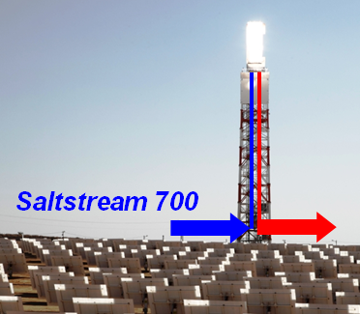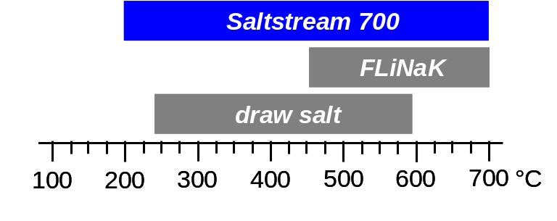

Figure 1: Target properties of advanced heat transfer fluid for central receiver plants.

Name | Manufacturer | Components | Melting point (liquidus) | Maximum temperature
draw salt | Coastal Chemical | sodium nitrate potassium nitrate | 240 °C | 593 °C
FLiNaK | Not commercially available | lithium fluoride  sodium fluoride  potassium fluoride | 454 °C | 700+ °C
Saltstream 700 | Halotechnics | TBD | 200 °C  (target) | 700 °C  (target)

Table 1: Candidate heat transfer fluids for concentrating solar power applications.

Technical Objectives
Halotechnics proposes developing a novel molten salt heat transfer and thermal storage material for central receiver solar thermal power plants. The objective of Phase 1 is to discover a group of salt mixtures that meet the following technical and commercial criteria. If these criteria are adequately assessed in Phase 1, an application for continuing to Phase 2 will be submitted.
- Melting point less than 200 °C
- Thermal stability as a liquid to at least 700 °C
- Low cost
- Chemical compatibility with high temperature steels
- Potential customer demand
Phase 1 will focus on the melting point and thermal stability and will not explicitly evaluate the cost or the materials compatibility of the salt mixtures; however, preference will be given to low-cost salt components and to salts known to be compatible with high temperature steels, when available. Cost and materials compatibility will be addressed in detail in Phase 2. Additional properties that are relevant for heat transfer fluid applications include the viscosity, specific heat, thermal conductivity, density, and vapor pressure. These properties will be measured in Phase 2 using standard methods or custom hardware if necessary. The commercial merit of Saltstream 700 will be determined in a continued dialog with potential customers. Discussions will include each customer’s desired physical properties, cost constraints, adoption timeline, field testing protocols, and quantity of material needed when deployed at full scale.

Phase 1 Research Plan

Eutectic Salt Mixtures
A dramatic reduction in the melting point of salt mixtures can be achieved by exploiting eutectic behavior. A eutectic mixture exhibits the lowest melting point of any similar mixture with the same components. The change in Gibbs free energy 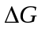 of a substance at the melting temperature T can be expressed in terms of the change in enthalpy 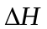 and the change in entropy 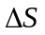.
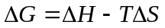
At equilibrium, = 0 and the melting temperature can be expressed as
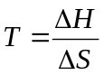.
Eutectic mixtures tend to disrupt intermolecular forces (reducing the change in enthalpy) or to increase the disorder generated upon melting (increasing the change in entropy). This leads to a reduction of the melting temperature.
Eutectic behavior is common with binary mixtures of salts, and can be even more dramatic with ternary mixtures. There has been significant work done both on modeling the phase behavior of binary and ternary mixtures of salts, as well as experimentally measuring their behavior [], []. The following examples highlight eutectic behavior in nitrate salts, but the same phenomenon occurs in carbonate, sulfate, chloride, and other salts. An example of a simple binary salt mixture is sodium nitrate and potassium nitrate (NaNO₃ and KNO₃) as shown in Figure 2. Sodium nitrate melts at 307 °C and potassium nitrate melts at 337 °C. This mixture has a eutectic point at 46 mol % NaNO₃ and 54 mol % KNO₃ which exhibits a drastically reduced melting point of 222 °C. This represents a melting point suppression of 85 °C from the lowest melting single component. An example of a ternary salt mixture is sodium nitrate, potassium nitrate, and lithium nitrate (LiNO₃). Lithium nitrate melts at 253 °C. The ternary mixture has a eutectic point at 18 mol % NaNO₃, 44.5 mol % KNO₃, and 37.5 mol % LiNO₃ which exhibits a melting point of 120 °C. The addition of lithium nitrate to the mixture achieves an additional melting point reduction of 102 °C as compared to the binary mixture.
Eutectic behavior and more drastic melting point reduction occurs with more complex salt mixtures, such as quaternary or higher order mixtures. There is limited experimental data of higher order mixtures; some recent work has been done on novel mixtures of nitrate salts to explore low melting point behavior []. This work discovered the existence of quaternary mixtures of nitrate salts (with Li, Na, K, and Ca cations) with melting points below 100 °C. Halotechnics has discovered high order mixtures with melting points below 75 °C [].
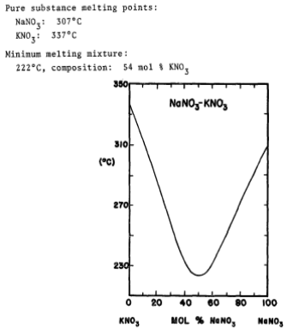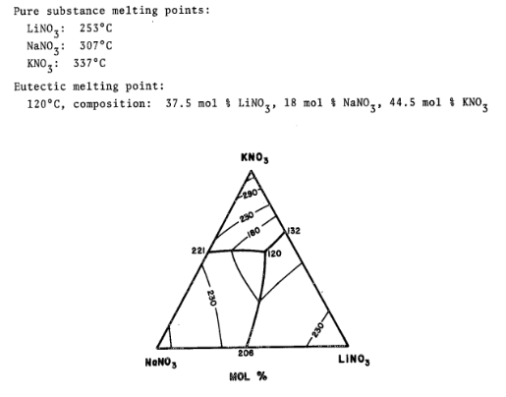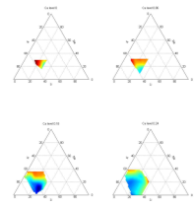
Figure 2: Binary, ternary, and quaternary phase diagrams of nitrate salts (Li, Na, K, Ca cations).

It is difficult to accurately model phase behavior of higher order salt mixtures. Detailed material properties of each component must be known, some of which must be measured experimentally. Existing databases of thermodynamic salt properties are incomplete, with many salts of interest (such as carbonates and sulfates) missing. It is therefore typically more straightforward to rely on experimental methods and to directly measure the phase behavior of a system of salts. The large number of possible combinations with higher order mixtures makes experimental work burdensome, since the number of possible combinations increases exponentially with the number of components. Eutectic behavior is quite sensitive to the weight percent of each component in the mixture; a deviation of only a few percentage points may have a significant effect on the resulting melting point. If one assumes that each component in a salt mixture can be controlled to the nearest percentage point, then with a two component system there are 101 possible combinations, with a three component system there are 5151 combinations, and with a four component system there are 176,851 combinations. The permutations increase correspondingly when one varies the components to explore different salt systems.

Transformative Research: Combinatorial Materials Science
Halotechnics will conduct a high throughput materials discovery program to rapidly screen over 2000 unique mixtures of inorganic salts and to discover new eutectic mixtures with a lower melting point and higher maximum temperature than draw salt. We will apply combinatorial chemistry techniques, originally developed for pharmaceutical applications, to a new field: solar thermal materials. This transformative research benefits from the large body of knowledge developed for over 15 years in combinatorial chemistry and uses this know-how to address the pressing problem of renewable power generation.
Salts such as carbonates, sulfates, and chlorides are commercially available in large quantities at low cost and are capable of high temperature operation. However, known eutectic mixtures have high melting points typically over 300 °C (see Figure 3). Discovering new eutectic mixtures is a combinatorial problem, since the number of possible mixtures increases exponentially with the number of components. Extensive data exists for binary and ternary phase diagrams of inorganic salts []. However, there is minimal data available for quaternary and higher order systems. Halotechnics has had direct experience and previous success in this type of work through the development of Saltstream 500 (primarily nitrate salts). Based on our experience in this field and existing literature data, we anticipate discovering eutectic mixtures with melting points significantly below those already known.
* A rigorous experiment design methodology for high dimensional salt mixtures will be used. The existing data for ternary eutectics of a given salt system (if available) will provide a starting point from which to begin exploring the quaternary and higher order phase space. The methodology for screening high order salt mixtures begins with the known behavior of the ternary baseline system (three salts containing four ions). A candidate 4th salt (one additional ion) is chosen and a campaign of experiments is designed to survey the quaternary phase space. The melting behavior is measured and any favorable trends with reducing melting point are further explored until it is determined that any available eutectic points have been discovered. Then the next candidate salt is measured. Data from the screening of candidate quaternary mixtures (systems with five ions) serves as a starting point for beginning the exploration of quinary phase space (six ions) and then higher order mixtures (seven ions or more). In this manner many feasible salts can be surveyed rapidly in mixtures containing six components or more. *
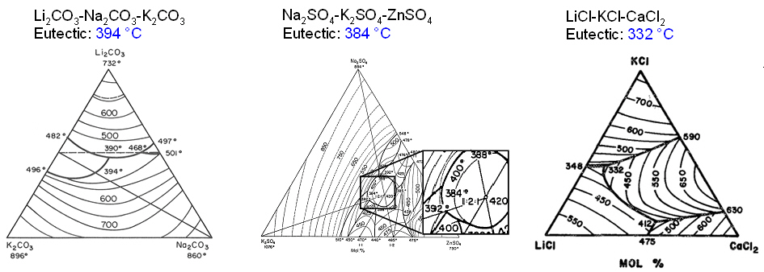
Figure 3: Promising eutectic salt mixtures to use as starting points for screening.

* An innovative method to plot high dimensional phase diagrams has been developed at Halotechnics and will be applied to this program. The phase diagram is a graphical device that allows the composition and melting point of mixtures to be represented simultaneously (this type of phase diagram is called a polythermal projection). The typical phase diagram is triangular, which allows the plotting of a ternary system of three salts (typically four ions). Each corner of the triangle represents a pure ion and the interior area represents mixtures of varying proportions. The color represents the melting point. A quaternary system of four salts (typically five ions) may be plotted by a series of triangular phase diagrams []. The location of each ternary diagram along a horizontal axis represents the proportion of the 5th ion. A quinary system of five salts (typically six ions) may be plotted by a two dimensional surface of ternary phase diagrams. Each ternary phase diagram is located at the (x, y) coordinates corresponding to the level of the 5th and 6th ions (ion 5, ion 6). A system of six salts (typically seven ions) may be plotted by a series of two dimensional surfaces of ternary phase diagrams. Each surface represents a constant value of the 7th ion. Figure 4 depicts an example of a seven ion phase diagram. *

Materials Discovery Workflow
In order to effectively map out the phase space in a reasonable amount of time, Halotechnics will combine the power of high throughput combinatorial discovery tools (for fast materials synthesis and characterization) with an optimized methodology for the design of experiments (to eliminate redundant or infeasible zones of the design space). The optimal mixture will represent a tradeoff between the melting point, cost, and other important properties for a commercially viable heat transfer fluid. Halotechnics has developed a complete workflow consisting of proprietary algorithms for designing constrained sets of experiments, automated scientific apparatus capable of screening up to 100 salt mixtures per day, as well as powerful software for graphically analyzing the results of high dimensional data for subsequent iteration. Halotechnics has licensed a suite of software applications from Symyx Technologies called Library Studio and Automation Studio that enable the rapid design of a library or group of experiments, as well as controlling the hardware and flow of data in an automated workflow. Figure 5 shows the data flow in this workflow.
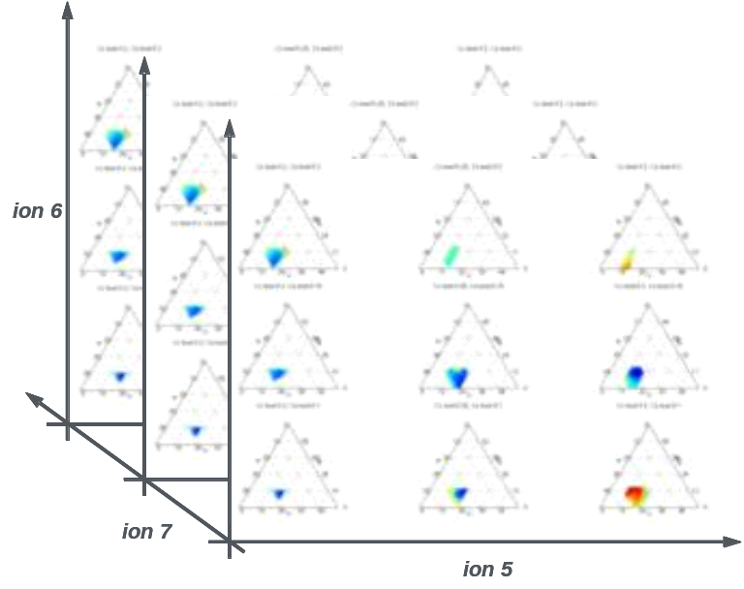
Figure 4: Six dimensional phase diagram (five in composition plus liquidus temperature).

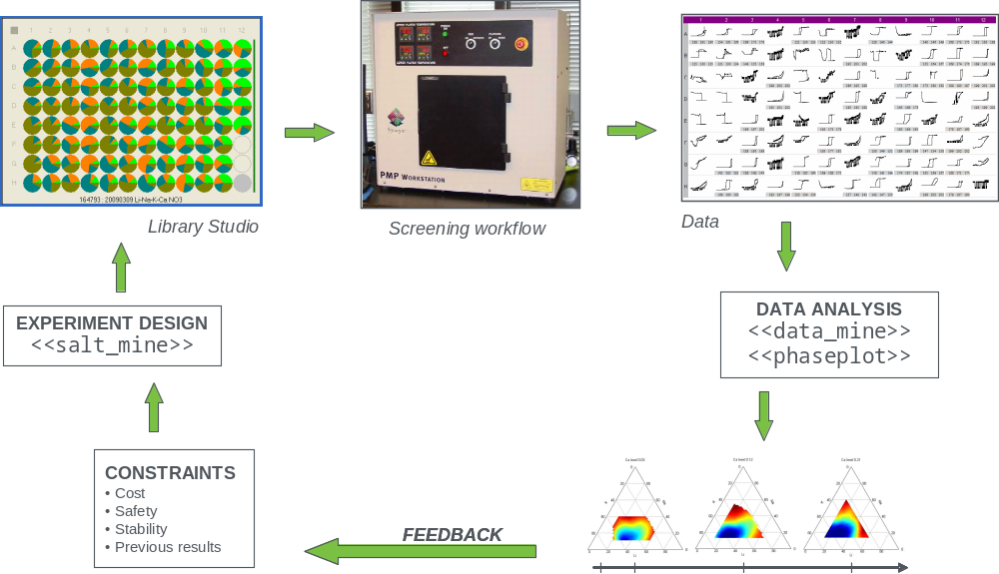
Figure 5: Data flow in the Halotechnics Materials Discovery Workflow.

Thermodynamic modeling will serve as a powerful tool to support the experimental activities focused on eutectic salt mixtures. Halotechnics has a license to the FactSage thermochemical software package and will use it to explore eutectic behavior of salt mixtures and equilibrium behavior of salt components. FactSage will be particularly useful in predicting the phase behavior of chloride salts. Its ability to predict the behavior of carbonate and sulfates is limited. The theoretical models will be used when appropriate to predict the performance of salt mixtures and strategically direct the experimental efforts and reduce the number of necessary tests.

Phase 1 Primary Screening
* The overall discovery program workflow is divided into a primary screen focused on melting point and thermal stability, and a secondary screen focused on other important heat transfer characteristics. Figure 6 shows a diagram of the materials screening workflow. Phase 1 will focus on the primary screen only. Phase 2 if awarded will complete primary and secondary screening as well as field testing. In general, first the primary screen will measure a large number of samples with a high throughput and eliminate the samples whose characteristics do not fall into the desirable range. An iterative formulation design process will be used with feedback from successive test results. Next, the secondary screen will more thoroughly characterize the performance of the samples that pass the primary screen, and will further reduce the number of candidates. Finally, the mixture optimization stage will determine the best tradeoff of thermal properties and cost. The resulting candidates from primary and secondary screening will be considered for scale-up field testing at Sandia National Laboratories or with potential customers. *
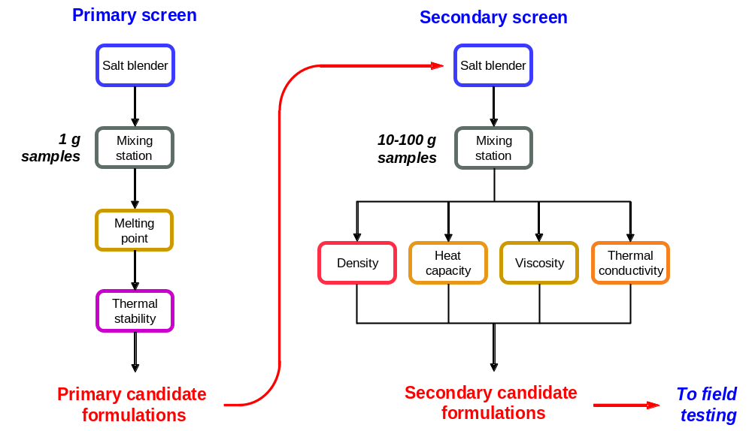
Figure 6: * Materials discovery screening workflow. *

* The melting point and the thermal stability are two critical performance aspects well suited for screening salt mixtures. The requirement of both a low melting point below 200 °C and a thermal stability up to 700 °C will eliminate a great number of candidate mixtures and will therefore function as an effective screen. The throughput of the primary screening workflow is expected to be 200 unique samples per week, including formulation, melting point and thermal stability measurement (if necessary), data analysis, and design of experiments. A discovery program of 10 weeks in Phase 1 will enable the testing of 2000 unique mixtures, which will provide adequate data to determine the feasibility of achieving the technical objectives by completing the discovery program in Phase 2. Assuming a selection rate of approximately 1% would generate 20 samples by the end of Phase 1 that meet the melting point and thermal stability target. The discovery of 20 unique mixtures with the target properties would embody solid experimental evidence that the technical objectives of the program will likely be met and would provide significant support to justify a Phase 2 application. Further work in Phase 2 would allow up to 5000 total unique mixtures to be screened. Halotechnics has extensive experience running high throughput discovery programs that operate in campaigns of several dozen to several hundred samples each. This method enables an efficient workflow that balances the rate of data generation with data reduction and analysis. *
* Salt blender: The first step in the workflow will be to design a set of salt mixtures that will be created by the automated salt blender. Salt mixtures will be formulated using automated robotic systems for both powder dispense and liquid dispense. The powder dispense system is the MTM Powdernium from Symyx Technologies (Sunnyvale, California). This device measures each component as it is being dispensed and records the final weight with high accuracy. It can dispense many different components to many different mixtures. The liquid dispense system is the Synthesis Station Core Module from Symyx. Components are typically dispensed as powder, but some hygroscopic salts may be dispensed as an aqueous solution to avoid forming clumps when in powder form. The mixtures will be dispensed into a borosilicate glass plate containing 96 wells in an 8 by 12 array. Each mixture will have a total mass of 250 mg. *
* Mixing station: The next step in the workflow is the mixing station (a high temperature muffle furnace) which will remove any solvent from the mixture and homogenize the mixtures by raising the temperature sufficiently high to melt all components and soaking for at least 8 hours. Each component must be melted and well mixed in order for the mixture to be properly tested. *
* Melting point: After mixing, the samples will be tested using a modified version of the Parallel Melting Point Workstation (PMP) from Symyx Technologies [], []. The PMP allows the melting point for each mixture in the 96 well plate to be measured simultaneously. Currently the PMP is capable of operation up to 300 °C; a modified version capable of 500 °C operation is being designed and will be used for Phase 1 work. This higher temperature is important for measuring the behavior of high melting point salt mixtures. The PMP heats the plate at a controlled rate and uses an optical method to record the temperature at which each mixture transitions from opaque to clear. This transition corresponds to the liquidus temperature, which is defined as the temperature during heating at which the last remaining solid phase melts and becomes liquid. The liquidus temperature is also equivalent to the temperature during cooling at which a solid phase first appears in the melt (assuming no supercooling). However, supercooling is common with molten salts and therefore only data acquired during a heating mode will be used to obtain the melting point. Figure 7 shows how the PMP works. A typical sample array and output data is shown in Figure 8. The results of the melting test will be used in iterative library designs to find the eutectic mixture of a given system of component salts. Halotechnics also has a differential scanning calorimeter (TA Instruments 2920 DSC) which can be used to accurately measure such thermal properties as melting point, heat of fusion, and specific heat. Its throughput is lower than the PMP so it will be used primarily to verify PMP results when appropriate. *
* Thermal stability: Mixtures that exhibit a low melting point will be subjected to further testing for thermal stability. In commercial use the salt mixture would experience most of its life at ambient pressure in the thermal storage tank; therefore thermal stability testing will be conducted at atmospheric pressure. Approximately 20 mg of each mixture will be scraped from its well in the glass plate and loaded onto a platinum pan for testing. The thermal stability of mixtures will be measured using a Q500 thermogravimetric analysis (TGA) device from TA Instruments (New Castle, Delaware). A TGA device heats a sample in a controlled environment and continuously measures the sample weight, which typically decreases at higher temperatures as the sample decomposes into gaseous products. The maximum temperature or thermal stability of a sample, termed ‘T3’, is defined for screening purposes as the temperature at which it has lost 3% of its anhydrous weight during a TGA test ramping at 10 °C/min. The anhydrous weight of a salt sample is defined as the weight at 300 °C during the TGA test. Initial weight loss below 300 °C is typically due to absorbed water evaporating from the sample. The T3 method ranks the mixtures in order of relative stability rather than acting as an absolute measurement of stability. In other words, this methodology does not provide a definitive prediction of the salt’s long term thermal stability in a real life application. It is primarily a laboratory scale screening test that gives a comparative ranking of candidate salt mixtures. Field testing to assess long term stability is planned for Phase 2. Figure 9 shows the TGA data from a measurement of draw salt in both air and nitrogen environments. *

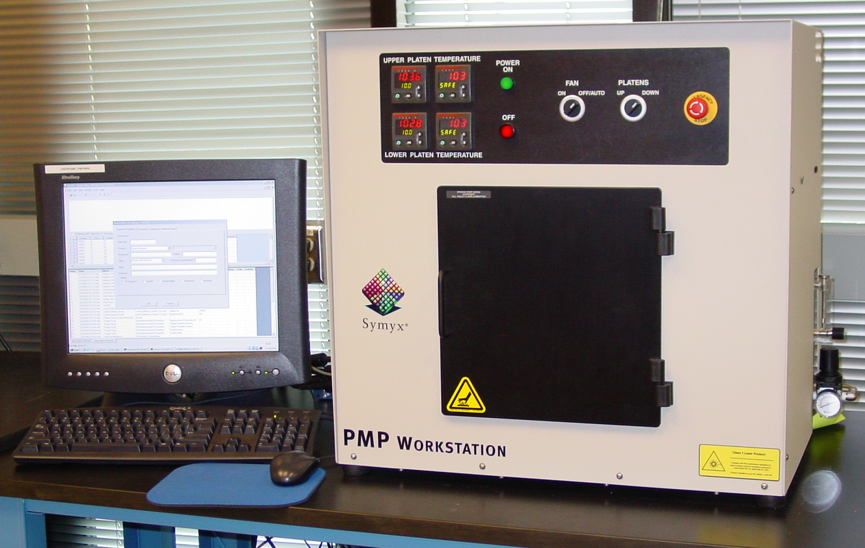
Figure 7: Symyx 96 channel Parallel Melting Point Tool (PMP).

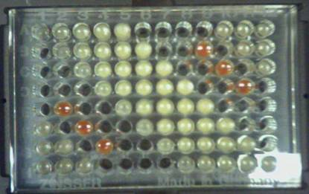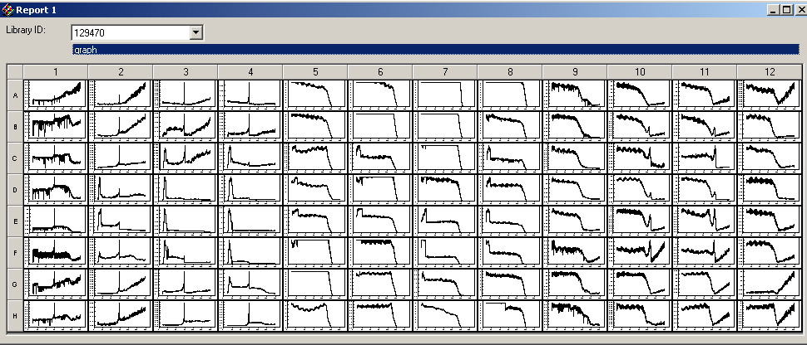
Figure 8: Typical sample array and output data from PMP.

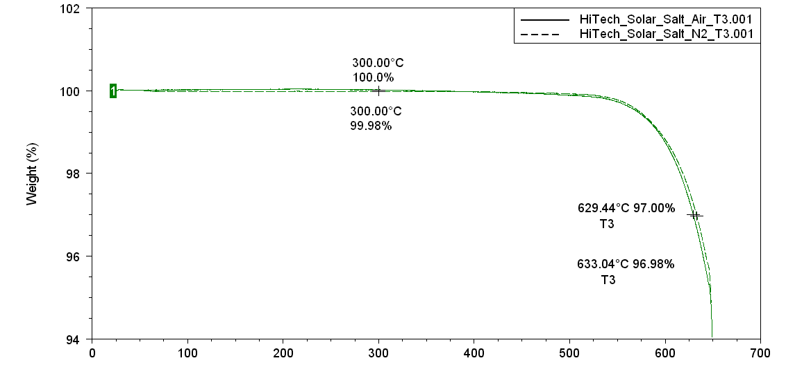
Figure 9: Thermal stability behavior of draw salt in air and nitrogen.

Detailed Execution Plan and Risk Mitigation
Objective: To discover a group of salt mixtures that meet the melting point and thermal stability targets. Figure 10 shows the tasks necessary to accomplish this objective. The first step will be to complete a literature review of the latest research and development work on high temperature heat transfer fluids as well as molten salts. There is extensive data on the characterization of molten salt eutectic behavior and thermodynamic properties. This literature will be consulted to facilitate an effective research direction and prevent unnecessary duplication of experimental data. Workflow method development consists of devising and optimizing the procedures for obtaining consistent data from each stage of the workflow. The method of dispensing the salt components for each mixture can be done with a dry powder dispensing technique or an aqueous solution based technique. Halotechnics has experience with many carbonate, sulfate, and chloride salts. New salts considered as mixture components must be assessed for their particular behavior in terms of hygroscopic tendency, ability to flow as a powder, and melting protocol. Once the workflow operation procedures are determined, the primary screen discovery phase will begin which will last 10 weeks. This task will consist of finding the eutectic point of a given system of salt components, and testing the thermal stability of the resulting eutectics. Each system of salts may have several related mixtures that meet the project objectives and each will be considered for further testing.
Key risks and recovery plan: There is a risk that no salt mixtures tested in Phase 1 will conform to the project objectives. For example, there may be a family of salt mixtures with low melting points but with insufficient thermal stability. The risk from this possibility is somewhat mitigated since there has been work showing salt mixtures that are within reasonable distance of the project objectives for melting point and thermal stability. This risk will be further reduced by the throughput and flexibility of the workflow. If a system of salt components is not generating candidates that meet both the melting point and thermal stability criteria, the search may be expanded to include more components or salts of a different variety. Additionally, a mixture with a very high thermal stability but a melting point of 250 °C instead of 200 °C may still be useful in central receiver plants or other applications. Field testing data from Phase 2 will serve to prioritize the project objectives and may reveal that a candidate that does not meet all objectives may still perform well in realistic situations.
There is little risk that the PMP discovery tool will not be able to effectively measure the melting point of the salt mixtures. The PMP has been used successfully for a previous discovery program at Halotechnics focused on nitrate salts.
There is a risk that the workflow will not achieve the throughput or sufficient weeks in operation to successfully screen the total number of desired mixtures. This risk will be addressed during the discovery program by using a flexible design of experiments methodology. If during the discovery program the total number of experiments is not on track to meet the initial target, subsequent library designs will be adjusted appropriately. It is possible that the available design space may be sufficiently explored with a number of experiments smaller than the initially proposed target.
Milestone 1: Approximately 20 primary candidate mixtures to be subsequently tested in Phase 2. The melting point of each must be less than 200 °C (250 °C allowable). Each must be thermally stable up to at least 700 °C (650 °C allowable).

Timeline and Staffing
Figure 10 shows the overall timeline of the project, assuming a successful Phase 1 and subsequent Phase 2 award. Phase 1 (6 months) will prove the feasibility of the concept by beginning the screening process in search of promising eutectic salt mixtures (2000 mixtures). Phase 2 is divided into two 12 month sections (Phase 2.1 and Phase 2.2). Phase 2.1 will complete the discovery program (screening an additional 3000 mixtures), perform secondary screening in order to downselect to a handful of promising candidates, and finally perform mixture optimization to determine the best combination of melting point, cost, and other important properties. Phase 2.2 will focus on field testing a handful of Saltstream 700 candidates with potential customers. The field tests will scale up the results from the laboratory to component level tests and on to pilot scale plants. At the conclusion of Phase 2 we plan to have at least one commercially viable composition to productize as Saltstream 700 and sell into the emerging solar thermal power market.
Figure 11 shows the staffing required for each quarter in Phase 1 and Phase 2. Phase 1 will be staffed by one scientist (PI), two research associates, and three interns. The PI will focus on experiment design, data analysis, and program management. The research associates will focus on experiment execution and data reduction. The interns (participating in the Halotechnics Internship Program, see next section) will each focus on a particular research project relevant to the technical or commercial objectives: (1) plant modeling using the NREL Solar Advisor Model [] with the goal of determining the economic value to a project developer of adopting of Saltstream 700; (2) supply chain analysis to determine the logistics and price of the raw materials that will be used to formulate Saltstream 700; (3) optimization of Saltstream 700 thermal properties (melting point, viscosity, heat capacity, etc) as a function of composition.

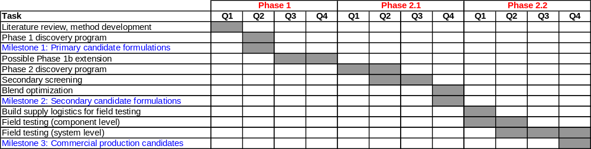
Figure 10: Overall project timeline.

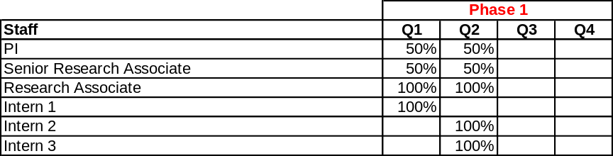
Figure 11: Project staffing for Phase 1.

Commercial Potential

Market Opportunity
* The solar thermal power market is an emerging industry with enormous growth potential. A recent report published by Greenpeace and the European Solar Thermal Electricity Association projects an installed capacity over 68,000 MW by 2020, enough to power over 50 million households. Annual installed capacity is projected to be over 12,000 MW per year by 2020 (half of which will be trough, half central receiver) with a typical plant size of approximately 250 MW. At the heart of these plants is the heat transfer fluid and thermal storage material. Each 250 MW central receiver plant will typically have six hours of thermal storage, requiring approximately 30,000 tons of a molten salt heat transfer/thermal storage material (trough plants will require significantly more due to less effective use of thermal storage). At an approximate sales price of $2/kg (higher than commodity salt materials, but lower than synthetic oil alternatives), the market for a Saltstream 700 heat transfer/heat storage material is projected to reach $1.5 billion by 2020. As a first mover in the field of molten salt heat transfer and heat storage material, Halotechnics stands poised to capture a significant portion of this emerging market. Our strategy is to gain first-mover advantage, build a name for the company by establishing a presence at industry conferences and trade shows, and to get out in front and keep innovating. Significant barriers to entry for competitors arise from our combination of compelling prototypes with IP protection, powerful product development capabilities with a top-notch team, and strategic business relationships. *

Company and Project Team
Halotechnics is a technology startup company in the San Francisco Bay Area developing advanced materials for heat transfer and heat storage focused on applications in the chemicals and energy industries. The innovation proposed here fits squarely into our company mission: to develop and commercialize advanced molten salt products. The core molten salt IP of Halotechnics was originally built at Symyx Technologies under the research of Justin Raade, PhD. Dr. Raade began his research with molten salt in 2007 and received a $1.5 million grant from the DOE in 2008 to develop advanced molten salt heat transfer fluids for trough plants. He led a multidisciplinary team at Symyx for one year under this program. During this program his team made an important breakthrough in novel eutectic salt mixtures, and at the end of 2009 he founded Halotechnics to spin out of Symyx and commercialize the result of this early work. Halotechnics has acquired from Symyx the powerful scientific equipment and software necessary for high throughput materials science research. Halotechnics has also acquired the IP related to molten salts from Symyx and is poised to continue innovative work in this field. There are currently four employees of Halotechnics and several part time consultants and advisors.
Halotechnics has a proven track record of early stage product development and is currently commercializing the results of Dr. Raade’s initial work. Our patent-pending Saltstream 500 product is a molten salt heat transfer fluid for applications in trough solar thermal power plants. Once commercialized, its unparalleled operating range of 75 °C to 500 °C will enable a 15% reduction in the levelized cost of electricity. Our core expertise leverages high throughput materials discovery methods to rapidly develop novel materials. We have developed powerful software tools and experimental apparatus for synthesizing and characterizing materials. As a spin-out from Symyx Technologies, we have a rich heritage in combinatorial chemistry that we are now using to solve materials related energy challenges.
Business Model and Customers
* Halotechnics will form strategic alliances with salt producers or other chemical suppliers. We will license these partners our enabling technology and leverage their existing supply chains and customer base. The solar thermal power industry is constrained by the requirements of project finance; every aspect of a $1-2 billion solar thermal plant must have a 20 year track record of proven performance, or have the guarantee of a company with a big balance sheet willing to back the technology. Halotechnics will seek partners able to provide such assurance for our products. We have a goal to achieve bankability (technology capable of securing project finance) with our products by 2013. *
Halotechnics is developing relationships with key potential customers for our Saltstream 500 and later Saltstream 700 products. Potential customers of Saltstream 500 include solar thermal technology companies such as Solar Millennium, Abengoa Solar, Siemens, and Acciona. These companies have expressed a strategic interest in adopting an advanced heat transfer fluid like Saltstream 500 with high stability and low melting properties. Other potential customers have expressed interest in a high temperature heat transfer fluid like Saltstream 700, including BrightSource Energy, SolarReserve, Pratt & Whitney Rocketdyne, eSolar, and Royal Dutch Shell (for in-situ oil shale conversion). Halotechnics is working closely with these customers to transfer the laboratory breakthroughs to field testing, pilot scale plants, and finally to full scale commercial plants.
Project Team
The management and advisory team at Halotechnics has deep experience in materials science and engineering, chemistry, and entrepreneurship. Advisors include a seasoned entrepreneur and experts from the high-tech and chemicals industries.
Justin W. Raade, PhD (PI) is CEO and Founder of Halotechnics. Dr. Raade is the PI on a $1.5 million grant (No. DE-FG36-08GO18144) from the Department of Energy under the Solar Energy Technologies Program. This award has funded the development of Saltstream 500. Dr. Raade has 9 years experience in cleantech and has lead several multidisciplinary R&D teams. He received an NSF Graduate Research Fellowship to support his doctoral research in Mechanical Engineering at UC Berkeley. His work there focused on applied thermodynamics and energy storage with hybrid systems using fuel cells and lithium polymer batteries. He has an undergraduate degree in Mechanical Engineering from MIT.
Thomas Roark is a Senior Research Associate at Halotechnics where he focuses on experiment execution and manages the laboratory facilities. Mr. Roark is a general chemist with over seven years of experience in high-throughput experimentation and parallel synthesis. Previously at ArQule, Inc. he worked as an organic chemist synthesizing compounds that were screened for anti-cancer drug applications. Later at Symyx Technologies he delivered automated materials discovery systems to top worldwide chemical companies to help drive their research.
Grady Hannah is Director of Business Development at Halotechnics where he focuses on developing customer relationships and building a product sales pipeline. Mr. Hannah has 10 years experience in Silicon Valley technology companies. He sold enterprise Linux solutions and Open Source cluster technology and later transitioned into the video game software market. Recently his sales led directly to a $10 million B Round while he was at Replay Solutions.
David Padowitz, PhD sits on the Advisory Board of Halotechnics. Dr. Padowitz is a leading expert on thermodynamic modeling, thermal stability enhancement, and molten salt chemistry. Dr. Padowitz has a PhD in Physical Chemistry from the University of Chicago with a focus on molecular kinetics and thermodynamics. He was as a Senior Staff Scientist at Symyx and previously was an Assistant Professor of Chemistry at Amherst College. At Symyx he led R&D on adsorption cooling systems, electrochemical energy storage, thin film photovoltaic materials, and transparent conductive oxides.
Michael Tenhover, PhD sits on the Advisory Board of Halotechnics. Dr. Tenhover has a PhD in Applied Physics from Caltech and is the President of Tenhover Consultants, a consultancy in the oil and gas industry. He was previously the Chief Scientist for Advanced Materials at British Petroleum and before that was the Chief Technology Officer of Hosokawa Micron Corporation. Dr. Tenhover specializes in the economic and technical analysis of inorganic materials and chemical processes.
Furthering Science and Engineering Education
Funds from this award would be used to expand the Halotechnics Internship Program. Under this program, science and engineering students work as a paid intern at Halotechnics under the supervision of a senior member of staff. Students are assigned a research project that will complement the education they are pursuing and provide them a practical outlet of the skills they learn in a classroom environment. The students receive mentorship from their supervisor who provides one-on-one tutoring, guidance, and relevant technical advice. The nature of this relationship is by necessity one of mentorship especially early in the internship but is intended to transition to one of supervised independent research as the student acquires a working knowledge of their project field. There are currently two students involved in the Halotechnics Internship Program, one from UC Berkeley and one from Stanford University. This award would expand the program to a total of 3-4 students. Typical project length is 3-6 months of full time work, with part time work possible during the academic year. Candidate interns are drawn from such majors as Chemistry, Materials Science and Engineering, Chemical Engineering, and related fields.
Impact on Job Creation
The funds from this award would allow Halotechnics to hire an additional full time research associate as well as 1-2 interns.

Competition
Several groups, such as Sandia National Laboratories and BASF, are researching molten salt for trough systems, but these materials are not suitable for central receivers because the operating temperature of troughs is lower. Research programs investigating novel concepts for thermal storage are underway at Terrafore, Lehigh University, DLR in Germany, and other groups. However, there are no known development activities underway focused on advanced heat transfer or thermal storage materials for central receiver plants.

Financial Projections
* Halotechnics plans to leverage its first mover status and enabling IP related to molten salt products to produce a lucrative royalty stream. We will work with our partners to assist in their field testing and scaling the commercialization of our products. This is not a passive “patent and wait” business model, rather we will be an active partner in seeing our products through to commercialization. We have projected a 10% royalty on sales, or $0.20 per kg of Saltstream 700 sold. Table 2 shows the projected revenues from this innovation through 2014. Saltstream 500 is a more mature product and the market for trough plants is somewhat more established, therefore revenues from this product will precede those from Saltstream 700. We are actively pursuing government grants for research focused on building our core IP. We are seeking private venture capital in order to scale our technology out of the lab and to the marketplace and bring us to break even in 2013 and profitability after that. We project the first full-scale commercial deployment of our products beginning in 2013. Our business model is capital-efficient and does not require a large amount of financing in order to develop a sustainable business. *

Financials ($k) | 2009 | 2010 | 2011 | 2012 | 2013 | 2014
Saltstream 700 Revenue |  |  |  | 350 | 1,450 | 2,900
Saltstream 500 Revenue |  |  | 500 | 780 | 2,900 | 5,800
Other Revenue | 500 | 250 | 650 | 500 | 400 | 400
Total Revenues | 500 | 250 | 1,150 | 1,630 | 4,750 | 9,100
Expenditures | 779 | 467 | 1,230 | 1,949 | 1,224 | 1,490
Net | (279) | (217) | (80) | (319) | 3,526 | 7,610

Table 2: * Halotechnics financial projection including Saltstream 700 sales. *

Consultants and Subawards/Subcontracts
There are no subawards, subcontracts, or consultants budgeted for Phase 1.

Equivalent or Overlapping Proposals to Other Federal Agencies
None. Halotechnics has a current award (No. DE-FG36-08GO18144) from the Department of Energy under the Solar Energy Technologies Program. The award is titled “Deep Eutectic Salt Formulations Suitable as Advanced Heat Transfer Fluids.” This award is focused on developing a molten salt heat transfer fluid for trough applications only and does not overlap with the proposed project to develop a central receiver heat transfer fluid. Trough plants have a lower temperature range (melting point below 80 °C, and a 500 °C maximum temperature) and therefore the heat transfer fluids consist of different materials (primarily nitrate salts).

[?] “Concentrating solar power outlook 2009,” Greenpeace International, SolarPACES, and ESTELA, 2009.
[?] “Survey of thermal storage for parabolic trough power plants,” subcontractor report NREL/SR-550-27925, 2000.
[?] “Baseload concentrating solar power generation,” FOA# DE-FOA-0000104, U.S. Department of Energy, awards announced May 7, 2010.
[?] “In situ conversion process fact sheet,” Royal Dutch Shell, May 2008.
[?] P. Masset and R. Guidotti, “Thermal activated (thermal) battery technology Part II. Molten salt electrolytes,” J. Power Sources, vol. 164, pp. 397-414, 2007.
[?] “Hitec solar salt,” Coastal Chemical Co., LLC.
[?] G. J. Kolb, “Conceptual design of an advanced trough utilizing a molten salt working fluid,” presented at SolarPACES Symposium, Las Vegas, Nevada, 2008.
[?] D. F. Williams, L. M. Toth, K. T. Clarno, “Assessment of candidate molten salt coolants for the advanced high temperature reactor (AHTR),” ORNL/TM-2006/12, 2006.
[?] P.L. Lin, A. D. Pelton, and C. W. Bale, “Computation of ternary molten salt phase diagrams,” J. American Ceramic Soc., vol. 62, no. 7-8, pp. 414-422, 1979.
[?] G. J. Janz et al., “Physical properties data compilations relevant to energy storage,” NSRDS-NBS 61, parts I, II, and IV, 1981.
[?] R. W. Bradshaw, J. G. Cordaro, and N. P. Siegel, “Molten nitrate salt development for thermal energy storage in parabolic trough solar power systems,” proc. ASME 3rd International Conference on Energy Sustainability, San Francisco, California, 2009.
[?] J. Raade, D. Padowitz, “Inorganic salt heat transfer fluid,” USPTO provisional application No. 61325725, 2010.
[?] Phase Diagrams for Ceramists, American Ceramic Society/NIST, vol. 1-4, 7, 1964-1989.
[?] Phase Diagrams for Ceramists, vol. 1 discusses this in the introductory material, for up to six ions.
[?] E. McFarland et al., “Optical systems and methods for rapid screening of libraries of different materials,” U.S. patent #6034775, 2000.
[?] D. Hajduk, “Depolarized light scattering array apparatus and method of using same” U.S. patent #6157449, 2000.
[?] P. Gilman, N. Blair, M. Mehos, C. Christensen, S. Janzou, C. Cameron, “Solar Advisor Model User Guide for Version 2.0,” NREL Report No. TP-670-43704, 2008.

